How to Use React DevTools to Inspect States and Props
To help ease your development, you can install the React Developer Tools (DevTools for short) to inspect the current state and props value of your components.
You can install React DevTool for Chrome here.
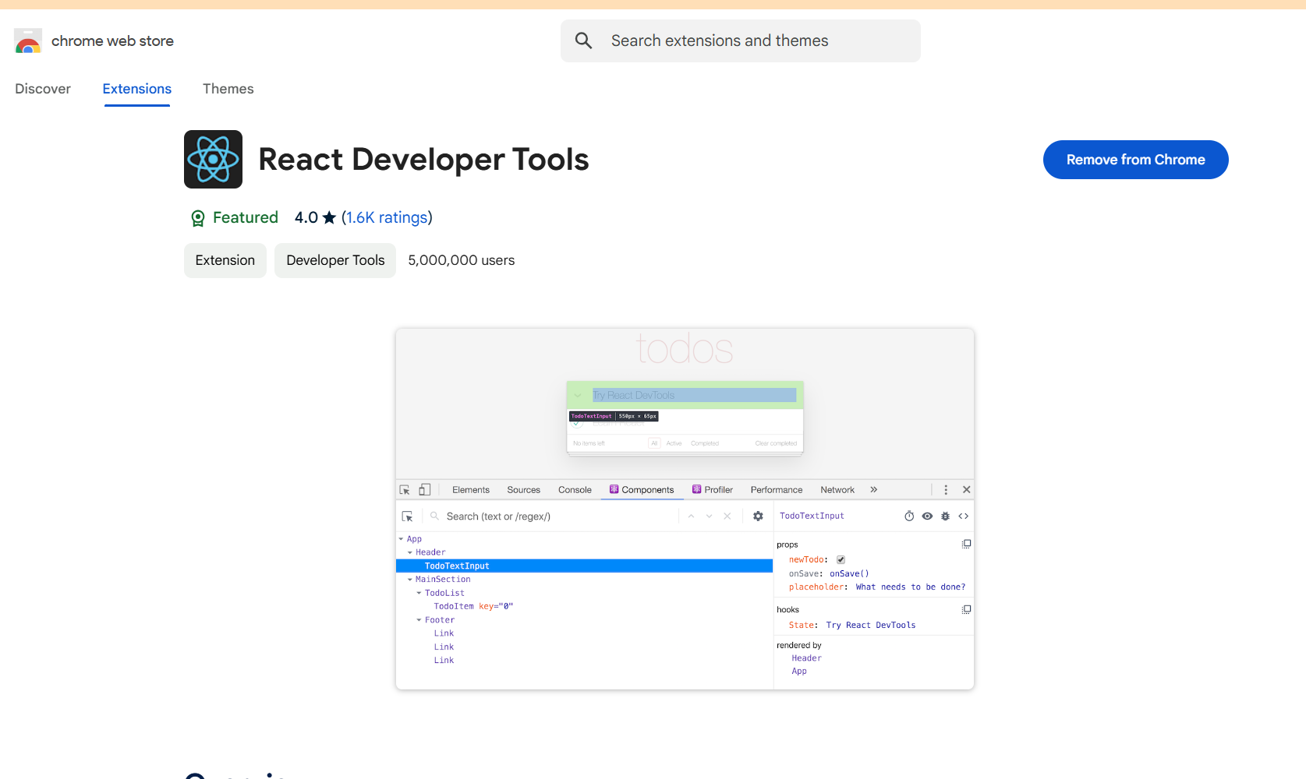

Once installed, open the developer tool and you should have two extra tabs called Components and Profiler as shown below:
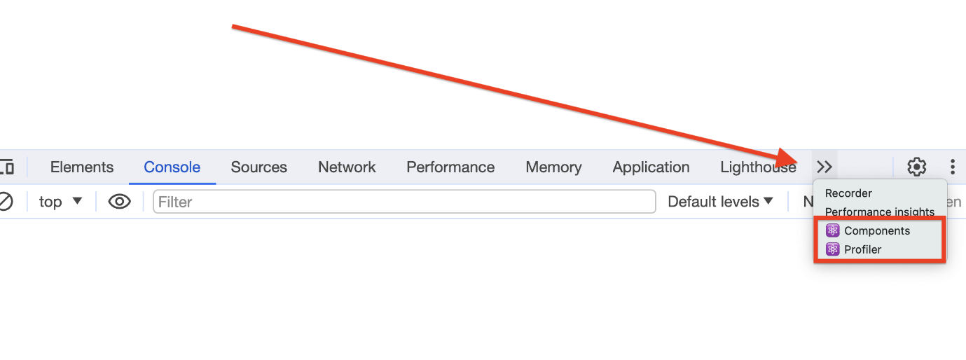Opening React DevTool
Similar to how you can inspect CSS rules applied to HTML elements, you can inspect the state and props of React components using the developer tools. Click the Components tab, and inspect one of the two components we created earlier.
Below, you can see the props and state of the ParentComponent, as well as other details:
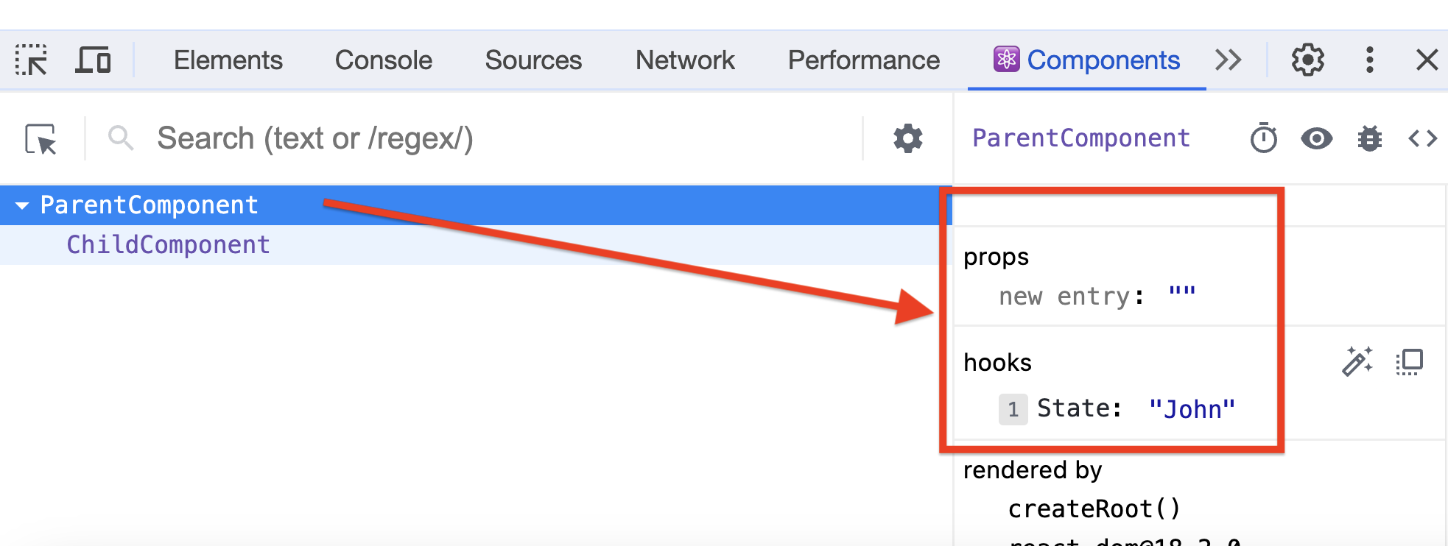Inspecting Components With React DevTool
When you click on the button, the state value will change accordingly. You can inspect the ChildComponent to view its details. These DevTools will come in handy when you develop React applications.

